Project 4: DNS and Multi-Account Strategy (Centralized DNS)

DNS is the phone book of the network: it turns a name like orders-db into an IP address. With many AWS accounts, one DNS setup per account becomes hard to manage. This project puts DNS in one central place.
- Central DNS account: one account owns the Route 53 Resolver endpoints and shared rules.
- Spoke accounts: they use the central setup instead of building their own.
- Hybrid: on-premises servers can find AWS names, and AWS apps can find on-premises names.
- Your job: own this design and keep the DNS patterns simple and standard.

Network diagram
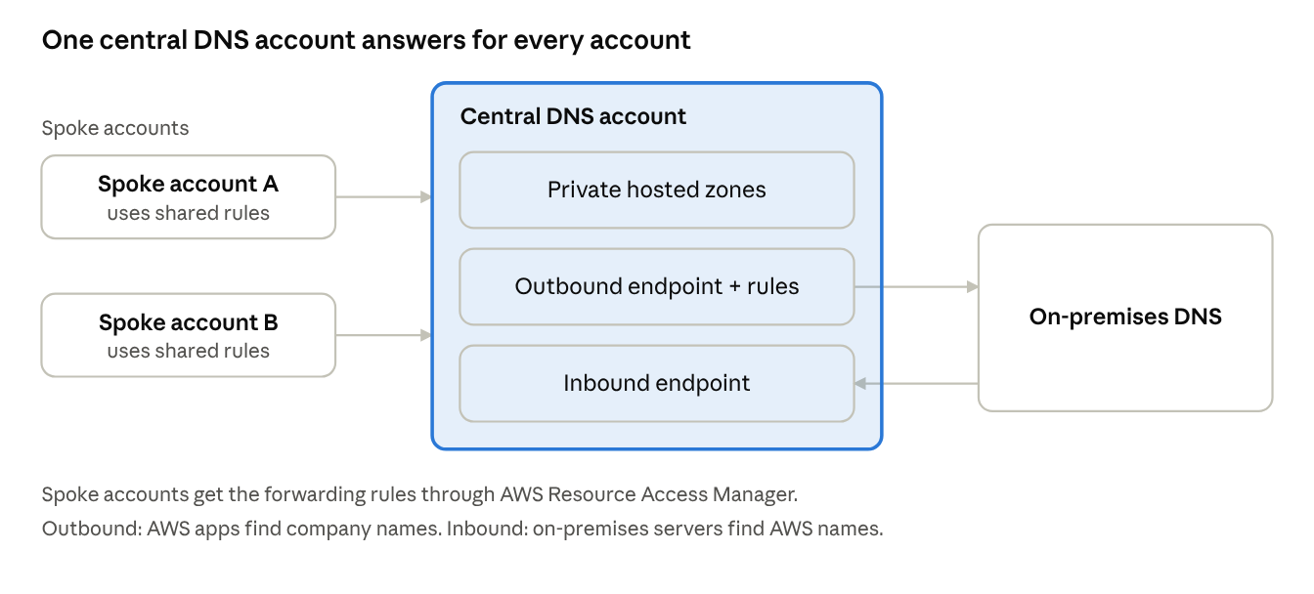
central DNS · spoke accounts and on-premises DNS
One account owns the DNS endpoints and rules. Spoke accounts reuse them, and the two Resolver endpoints connect AWS with on-premises DNS.

Standard DNS patterns
Pattern | In simple words
Private hosted zones | Private names for AWS resources, linked to every VPC that needs them, including VPCs in other accounts.
Resolver inbound endpoint | Lets on-premises servers ask AWS for AWS names.
Resolver outbound endpoint and forwarding rules | Lets AWS apps ask on-premises DNS for company names.
Shared rules | Forwarding rules are shared to other accounts with AWS Resource Access Manager, so nobody copies them by hand.
Naming convention | One naming pattern for all accounts, so names are easy to guess and manage.

Production use case
Example scenario: a company has 60 AWS accounts and a corporate data centre. An on-premises billing system must call an API in AWS, and AWS apps must look up a corporate directory server.
- The central DNS account holds the Resolver endpoints and the forwarding rules.
- The on-premises DNS forwards AWS names to the inbound endpoint.
- AWS apps in any account use the shared outbound rule to find corporate names.
- A new account joins, accepts the shared rules, and DNS works with no extra setup.
Result: fewer DNS mistakes, fewer custom setups, and faster onboarding of new accounts.

Interview questions and answers
Practice questions at the depth that senior cloud-network interviews at companies like AWS, Google and Meta expect. They are not official lists.
Q1. Design DNS for 100 AWS accounts and an on-premises data centre.
Put Route 53 Resolver endpoints in one central account. Use an inbound endpoint for on-premises queries to AWS and an outbound endpoint with forwarding rules for AWS queries to on-premises. Share the rules with Resource Access Manager. Associate private hosted zones with the VPCs that need them.
Q2. How do you avoid DNS loops between AWS and on-premises?
Forward each domain in one direction only. AWS-owned names resolve in AWS, company names resolve on-premises. Never forward a domain to a server that forwards it back. Document the owner of each zone.
Q3. How does a private hosted zone work across accounts?
The VPC in another account must be associated with the zone. This needs an authorization from the zone owner and then the association. At scale, automate this in the account-onboarding pipeline.
Q4. A name does not resolve in a spoke VPC. How do you troubleshoot?
Check in order: is the VPC associated with the zone, does a forwarding rule match the name, is the rule shared and applied to this VPC, do security groups allow DNS to the endpoints, and does the on-premises server answer. Resolver query logs show where it stops.
Q5. What is split-horizon DNS and when do you use it?
The same name gives different answers inside and outside the network. Example: an app name resolves to a private IP inside the VPC and a public IP on the internet. Use it so internal users stay on private paths.
Q6. What scaling limits matter for DNS in AWS?
There is a query limit per network interface to the VPC resolver, and quotas on endpoints and rules. Spread heavy clients, cache results, and check the current AWS quotas page, because limits can change.

